STUDENT ENROLLMENT AND COURSE MANAGEMENT SYSTEM
(SECMS)
Project work submitted to Thiruvalluvar University, Serkkadu, Vellore.
In partial fulfillment for the award of degree
BACHELOR OF SCIENCE
IN
COMPUTER SCIENCE
By
Team ID: SWTID-2026-3556
Team Leader: LOGESWARAN R (20924U18098)
Team Member: LOKESH M (20924U18099)
Team Member: MADHAN BABU B (20924U118100)

DEPARTMENT OF COMPUTER SCIENCE
SHANMUGA INDUSTRIES ARTS &SCIENCE COLLEGE
Accredited with “B+” Grade by NAAC,
Certified Under Section 2(f) & 12B of the UGC Act 1956,
An ISO 9001:2015 Certified Institution
Permanently Affiliated to Thiruvalluvar University, Vellore,
Approved by Govt. of Tamil Nadu & AICTE,
Tiruvannamalai – 606603.

OCTOBER – 2026

INTRODUCTION

The Student Enrollment System is a Salesforce-based application designed to streamline and automate the complete student admission process for educational institutions. This system manages the entire lifecycle from student registration, course selection, instructor assignment, to enrollment approval and fee tracking. Manual enrollment processes are time-consuming and error-prone. This project leverages Salesforce's powerful declarative tools including Custom Objects, Flows, Approval Processes, Validation Rules, and Dashboards to create a centralized, automated, and user-friendly enrollment management solution. The system ensures data accuracy, reduces administrative workload, and provides real-time insights through reports and dashboards. Key Features: Centralized student, course, instructor, and enrollment data management Automated enrollment date assignment and instructor allocation using Flows Multi-level approval process for enrollment requests Duplicate prevention and data validation rules Role-based access through custom Profiles and Role Hierarchy Real-time dashboard with enrollment statistics and revenue tracking.

1.1. USER STORIES:
1. As an Admin,
I want to manage all students, courses, instructors, and enrollments from a single app, so that I can oversee the entire admission process efficiently.
2. As an Admin,
I want the enrollment date to be set automatically when a new enrollment is created, so that I can avoid manual entry errors.
3. As an Admin,
I want instructors to be assigned automatically based on course category (Technical / Language / Non-Technical), so that allocation is fast and accurate.
4. As a Student,
I want to enroll in courses easily and view my enrollment status, so that I can track my admission progress.
5. As an Instructor,
I want to view only my assigned courses and enrolled students, so that I can focus on my teaching responsibilities.
6. As an Admin,
I want an approval process for enrollments, so that only verified enrollments are confirmed.
7. As an Admin,
I want to prevent duplicate student records, so that data remains clean and accurate.
8. As an Admin,
I want a dashboard showing student count, enrollments per course, and revenue, so that I can make data-driven decisions.
1.2 Purpose:
The purpose of the Student Enrollment and Course Management System is to provide educational institutions with a centralized, automated platform on Salesforce to manage the complete student admission lifecycle efficiently. This system aims to eliminate manual errors and delays caused by spreadsheet-based enrollment by automating key processes such as enrollment date capture, instructor assignment based on course category, and approval workflows. It ensures data accuracy through validation rules and duplicate prevention, while maintaining strict data security through role-based profiles and hierarchy. Furthermore, the system provides administrators with real-time insights through reports and dashboards on enrollments, course demand, and revenue, enabling faster and better decision-making. Overall, the purpose is to improve operational efficiency, enhance student experience, and create a scalable digital foundation for enrollment management.

2. IDEATION PHASE:
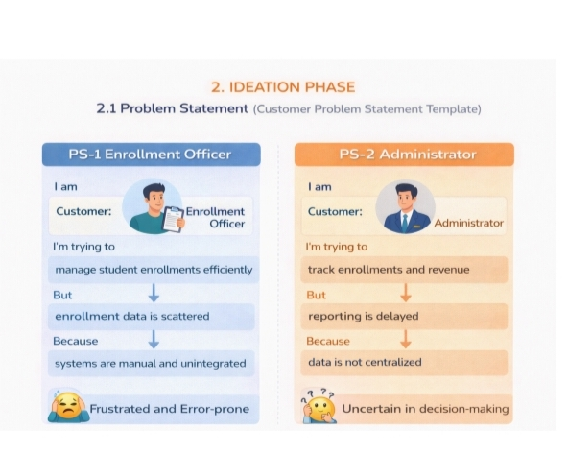

2.1 Problem Statement
Educational institutions manage student admissions manually using spreadsheets and paper records. This leads to data duplication, delayed enrollments, instructor allocation errors, and lack of real-time insights. A centralized automated system is needed to streamline the enrollment process.

2.2 Empathy Map Canvas Says:
Admin says "enrollment tracking is messy", Student says "I don't know my admission status" Thinks: Admin thinks about data errors, Student thinks about delays Does: Admin manually enters data in Excel, Instructor waits for allocation Feels: Frustrated due to workload, anxious about admission confirmation.
2.3 Brainstorming & Idea Prioritization:
Ideas generated: Online enrollment form, auto instructor assignment, approval workflow, dashboard, SMS alerts, payment integration.
Prioritized: Auto enrollment date (High), Auto instructor assignment (High), Approval process (High), Dashboard (Medium), Payment gateway (Low - future scope).

3. REQUIREMENT ANALYSIS PHASE
3.1 Customer Journey Map:
Student visits institution → 2. Fills enrollment request → 3. Admin verifies details → 4. System auto-assigns instructor → 5. Approval → 6. Student receives confirmation → 7. Admin tracks via dashboard

3.2 Solution Requirement:
Functional Requirements: Manage Student, Course, Instructor, Enrollment records Auto-set enrollment date using Flow Auto-assign instructor based on course category Approval process for enrollment Duplicate prevention Non-Functional Requirements: Role-based security via Profile’s Lightning responsive UI Data accuracy through validation rules.
3.3 Data Flow Diagram:
Student → Enrollment Request → Salesforce (Validation → Flow Automation → Approval) → Instructor Assignment → Dashboard Reports → Admin
3.4 Technology Stack Platform:
Salesforce Lightning Platform Automation: Record-Triggered Flows, Approval Process Security: Profiles, Roles, Sharing Rules Analytics: Reports & Dashboards Data: Data Import Wizard
4. PROJECT DESIGN PHASE-I
4.1 Problem - Solution Fit:
Problem: Manual enrollment causes errors and delays. Solution: Salesforce automation handles validation, auto-assignment, and approvals centrally, fitting the need perfectly.
4.2 Proposed Solution:
A Salesforce Lightning App "Student Enrollment App" with 4 custom objects, 2 flows for automation, approval process, 3 profiles for security, and dashboard for insights.

4.3 Solution Architecture:
User Layer (Lightning App) → Data Layer (Student, Course, Instructor, Enrollment objects) → Logic Layer (Flows, Validation Rules, Approval Process) → Security Layer (Profiles, Roles) → Analytics Layer (Reports, Dashboard)
5. PROJECT PLANNING & SCHEDULING
5.1 Project Planning:
Sprint 1: Requirement analysis, Object & field creation
Sprint 2: Page layouts, Tabs, Profiles, Roles
Sprint 3: Flows, Validation rule, Duplicate rule, Approval process
Sprint 4: Data import, Reports, Dashboard, Testing & Documentation Product Backlog: Custom objects (Done), Automation flows (Done), Approval (Done), Security setup (Done), Dashboard (Done)

6. PROJECT DEVELOPMENT PHASE:
6.1. DEVELOPER EDITION

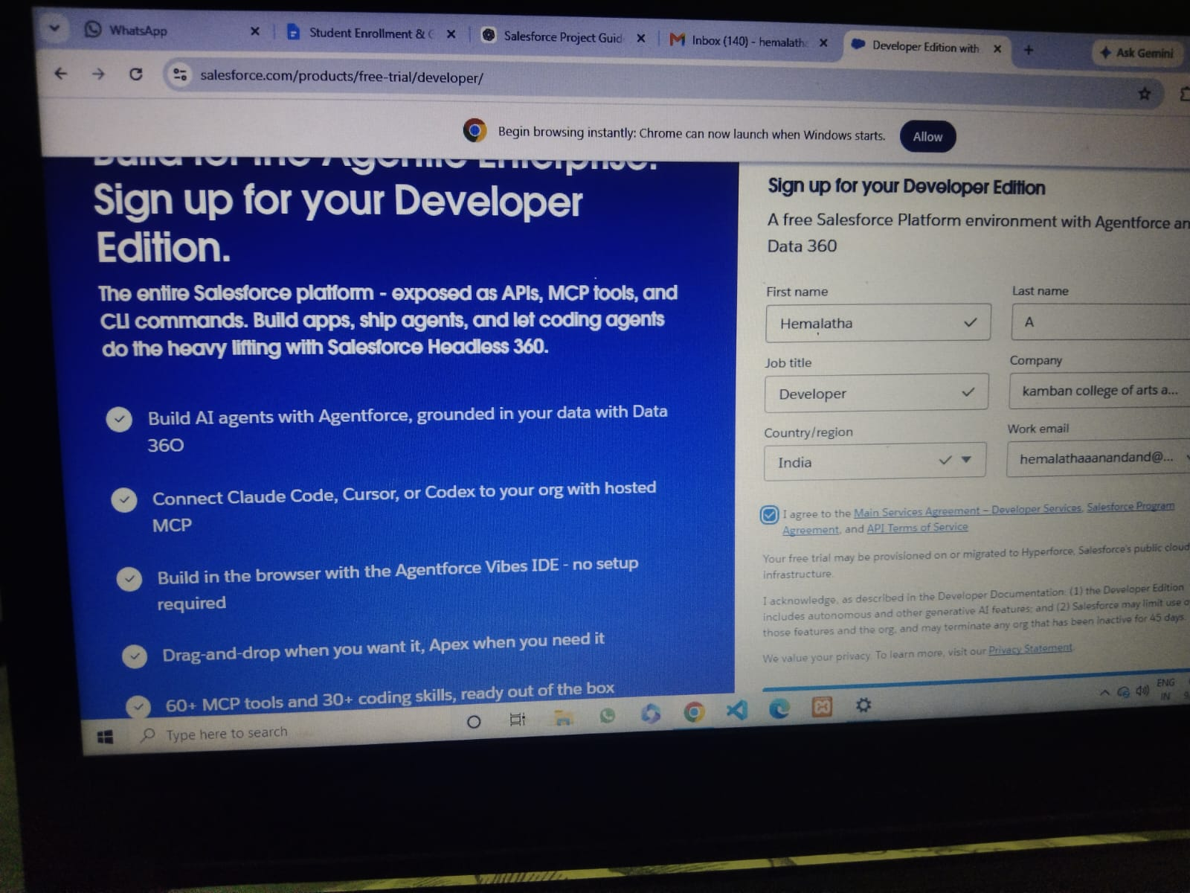

6.2. DEVELOPER ORG HOME PAGE
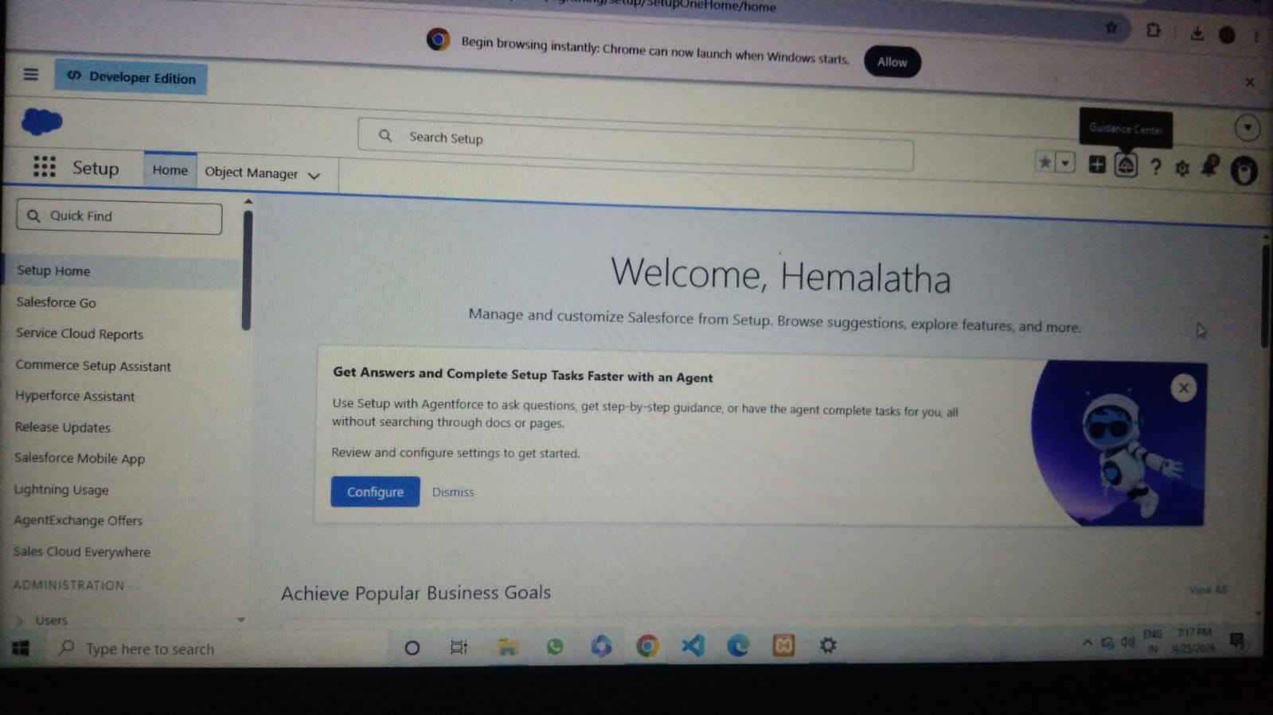

6.3. STUDENT OBJECT
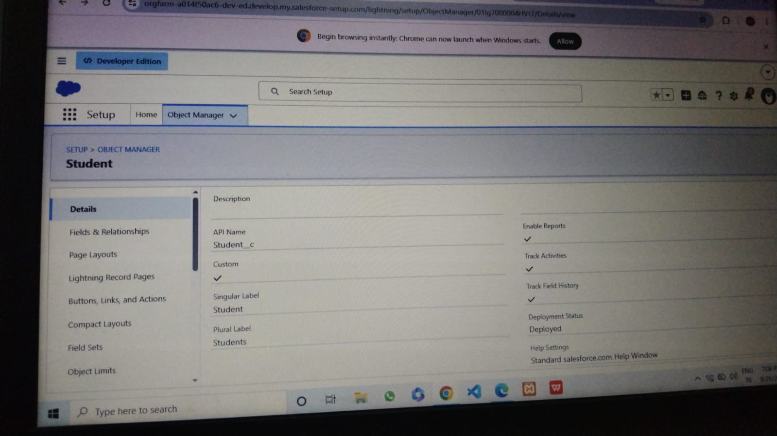

6.4. COURSE OBJECT
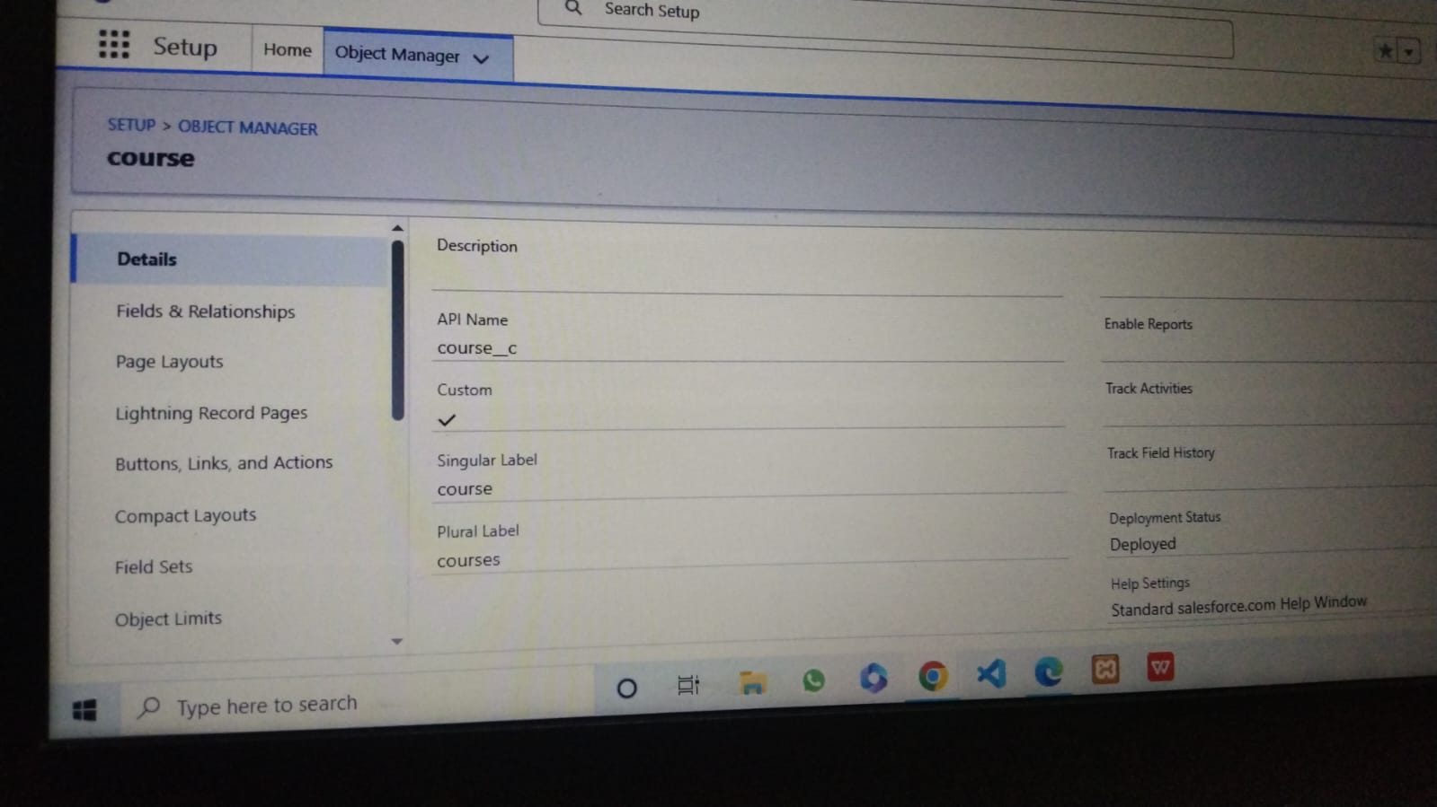

6.5. INSTRUCTOR OBJECT
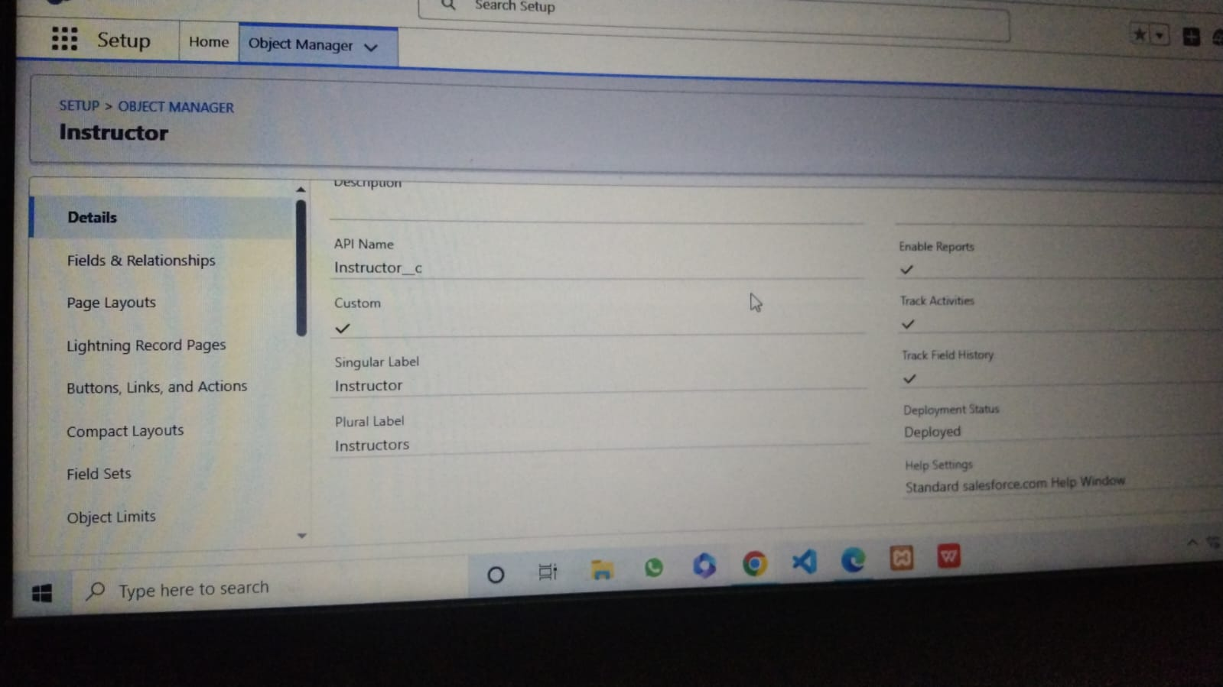

6.6. ENROLLMENT OBJECT
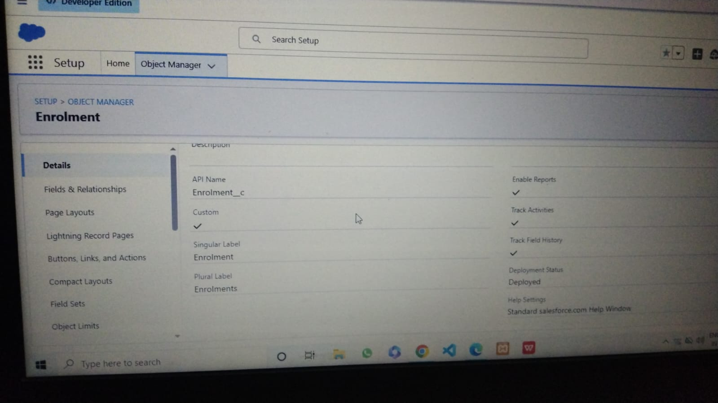

6.7. STUDENT FIELDS
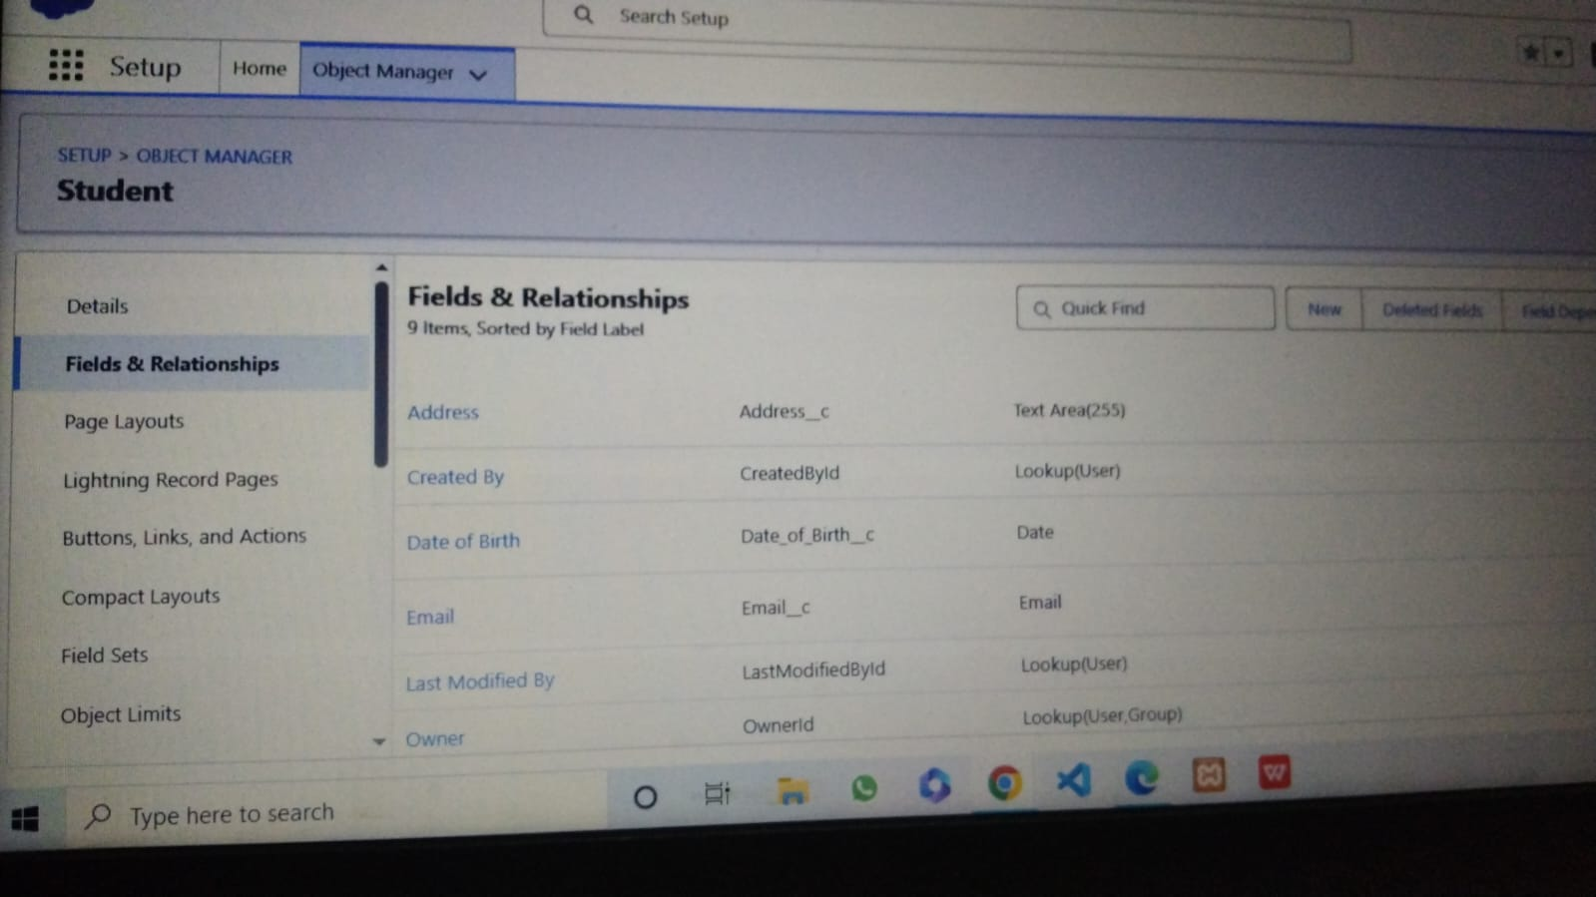

6.8. COURSE FIELDS
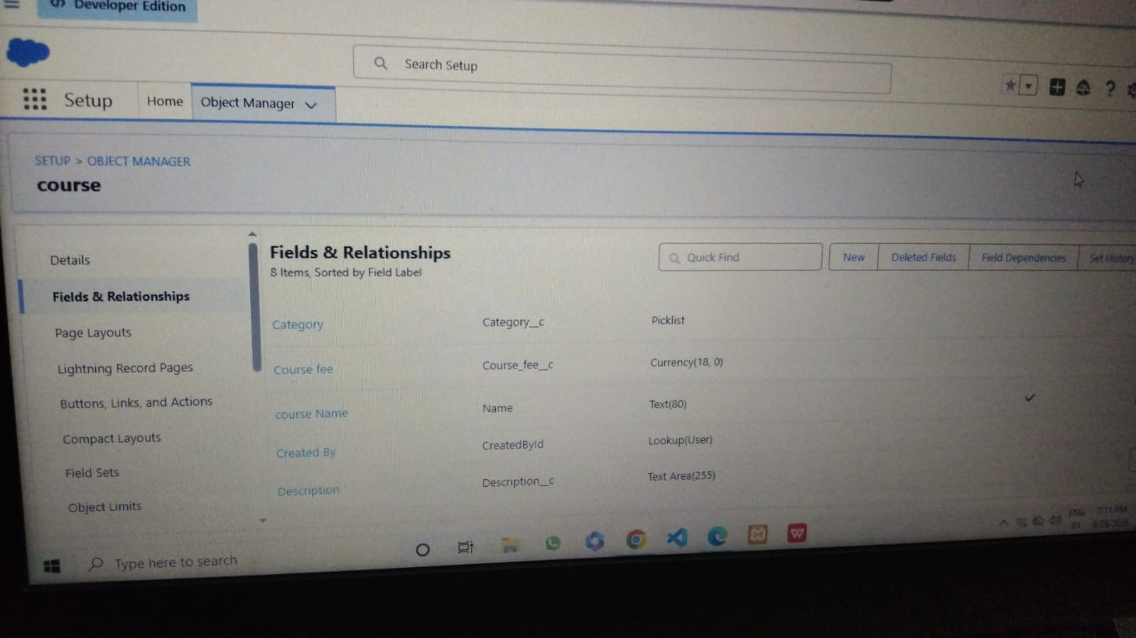

6.9. INSTRUCTOR FIELDS
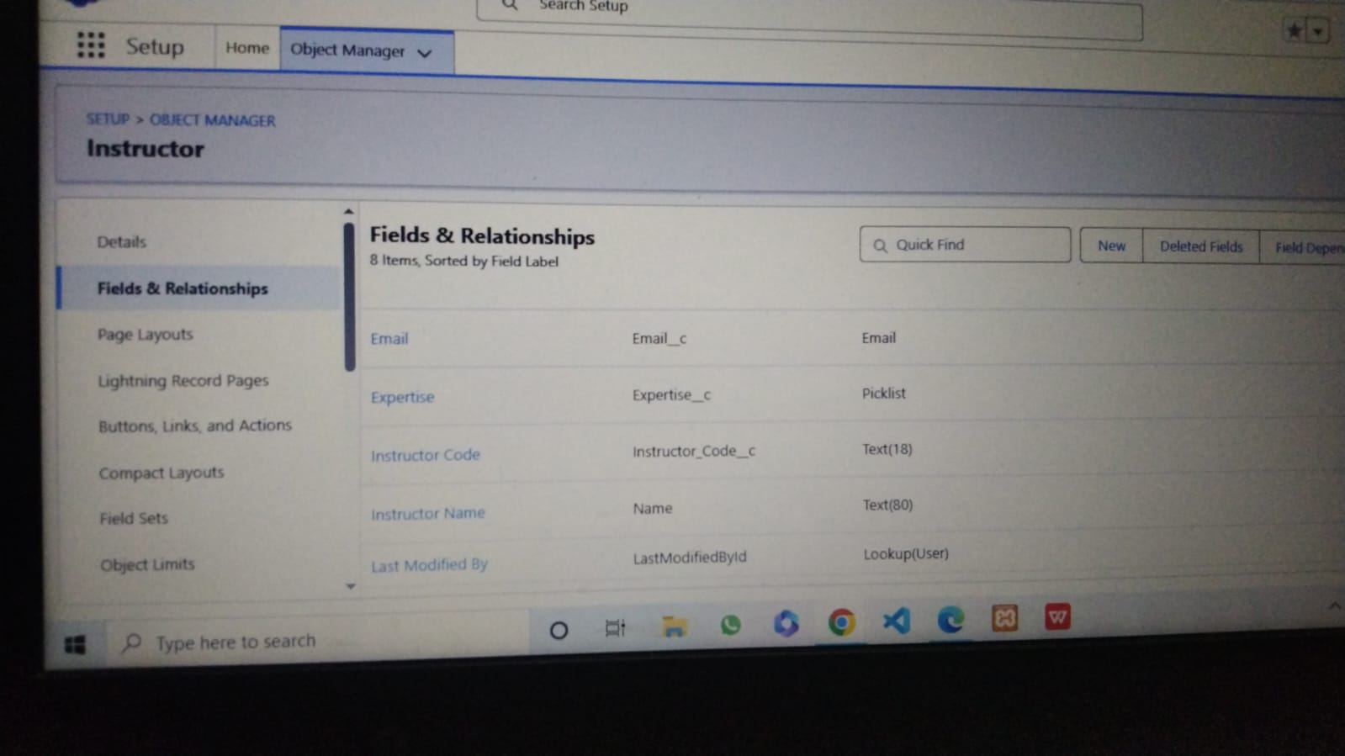

6.10. ENROLLMENT FIELDS
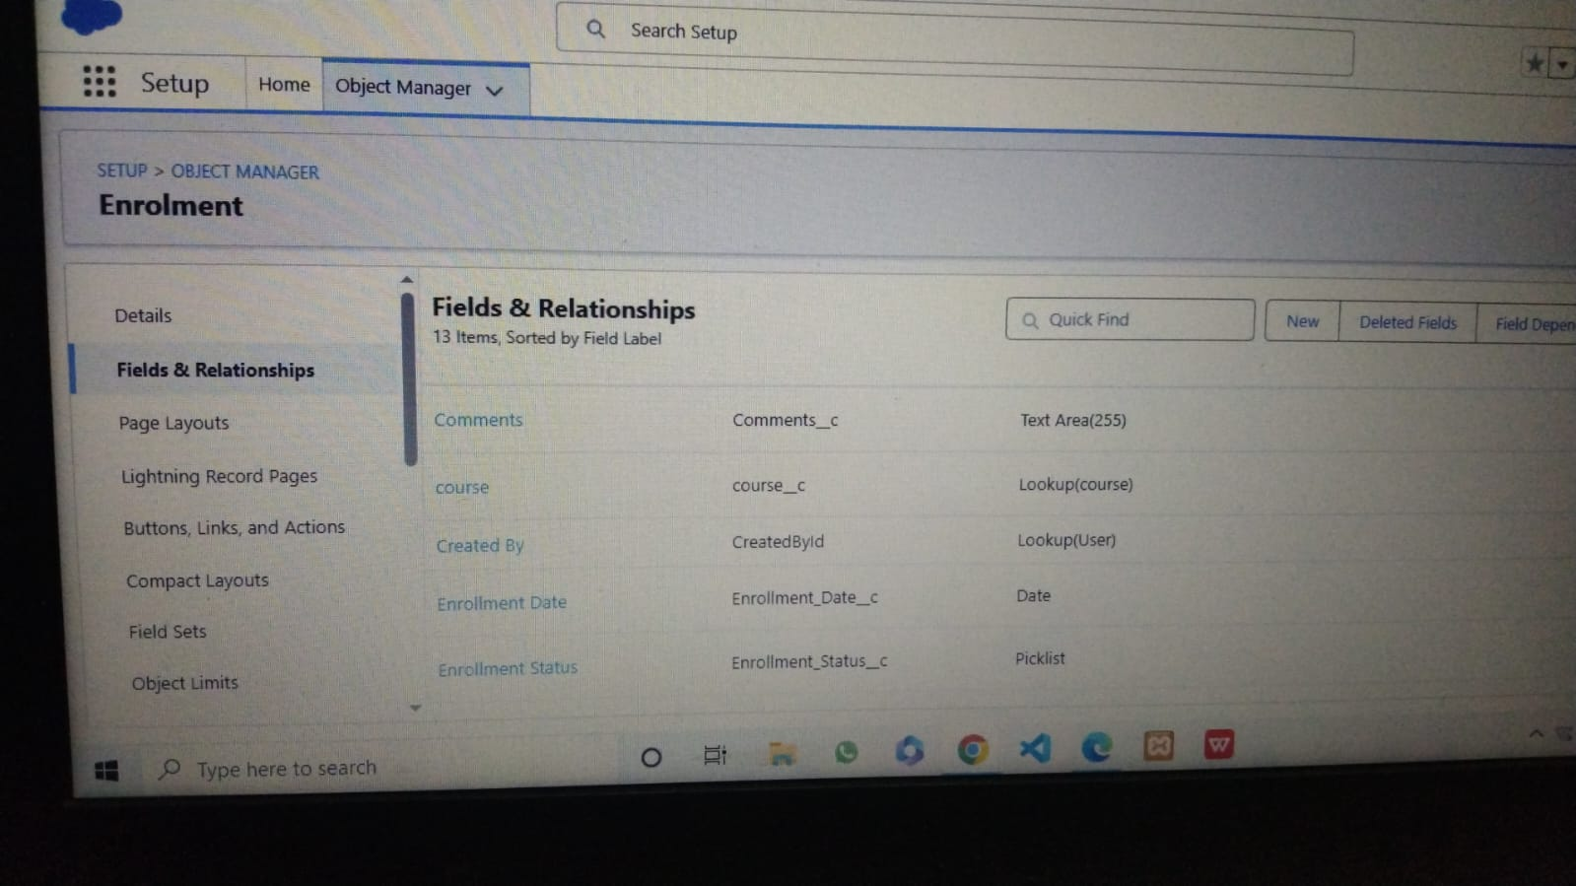

6.11. ENROLLMENT STUDENT LOOKUP
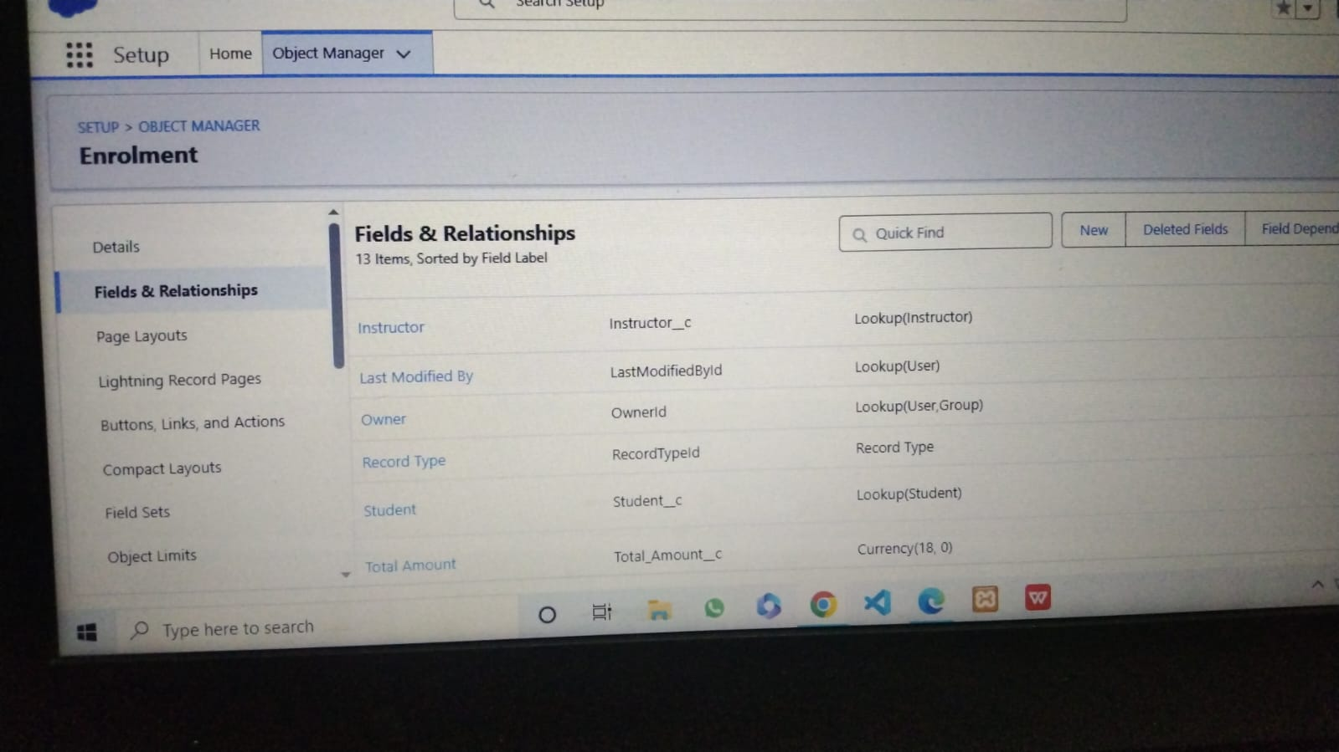

6.12. ENROLLMENT INSTRUCTOR LOOKUP

6.13. EMAIL VALIDATION ERROR
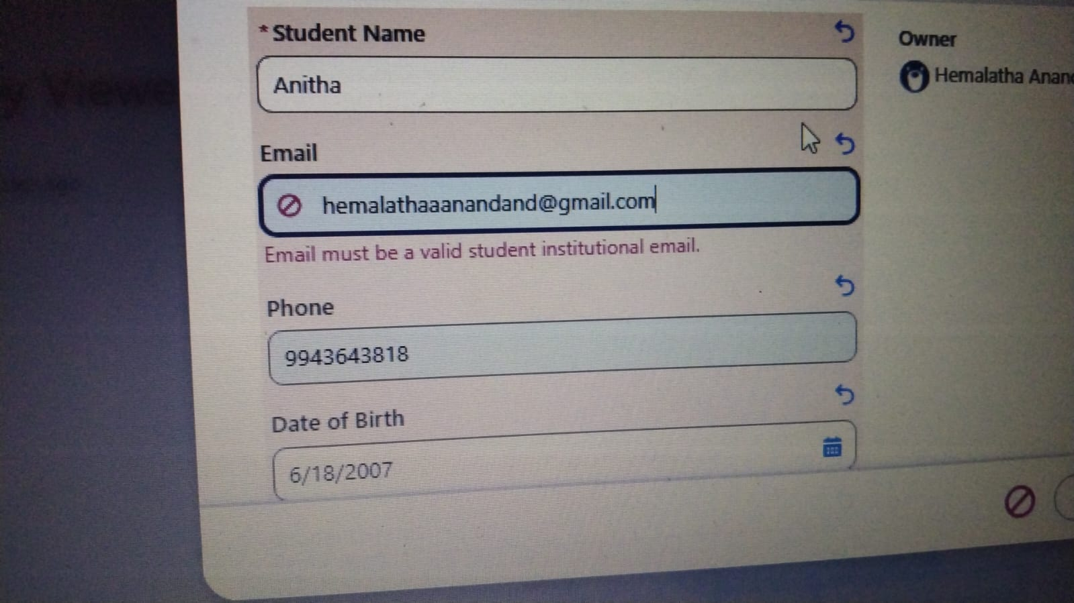

6.14. FEES VALIDATION ERROR
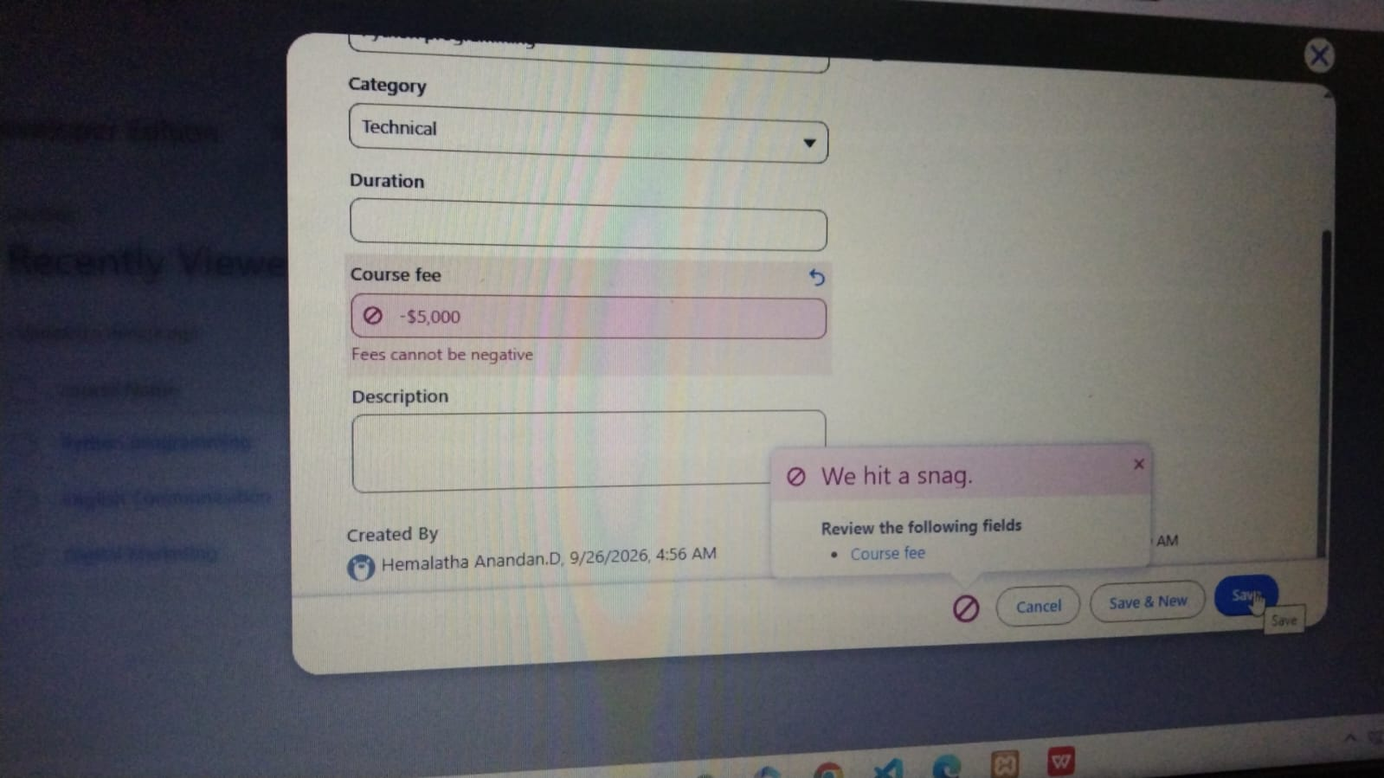

6.15. APPROVAL PROCESS PAGE
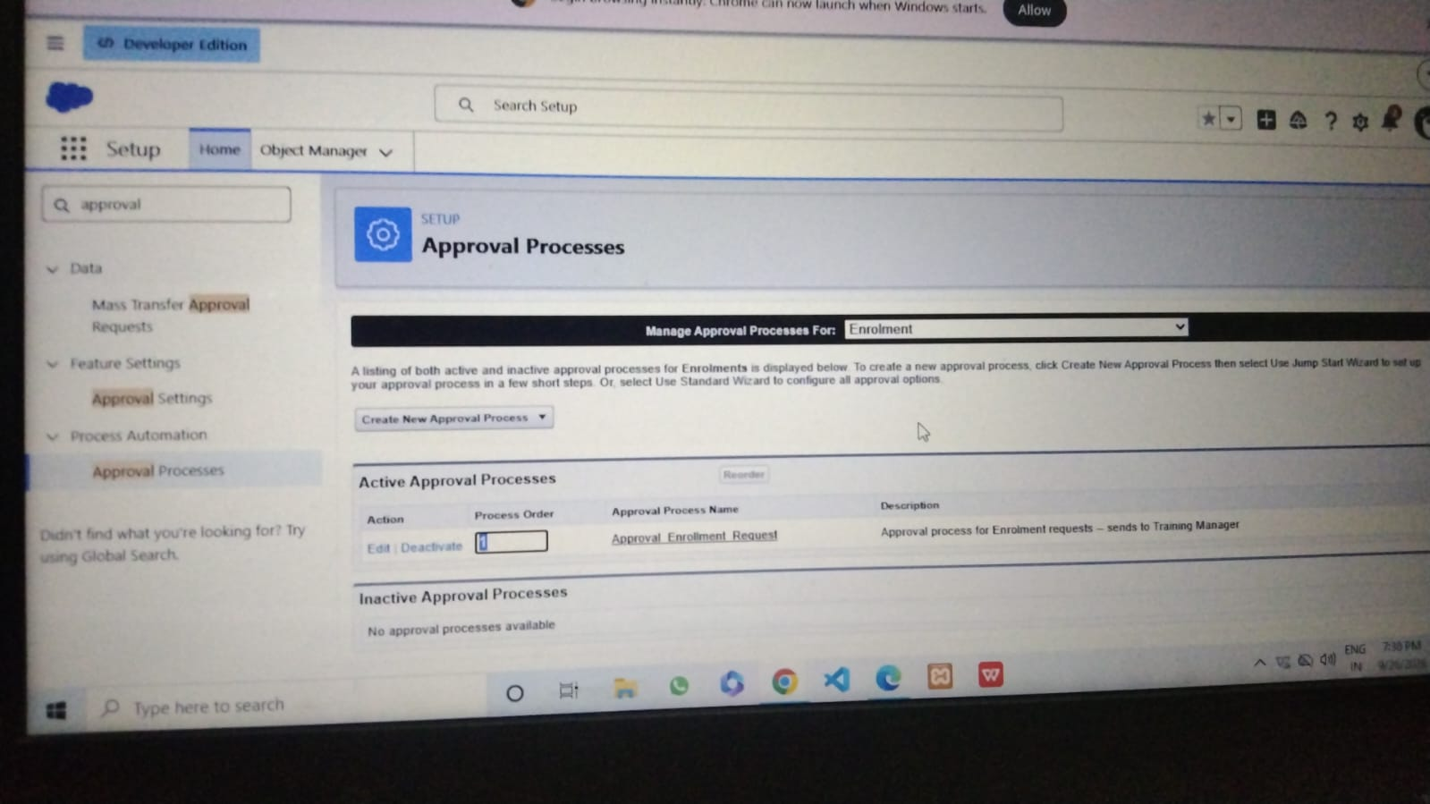

6.16. LIGHTNING APP
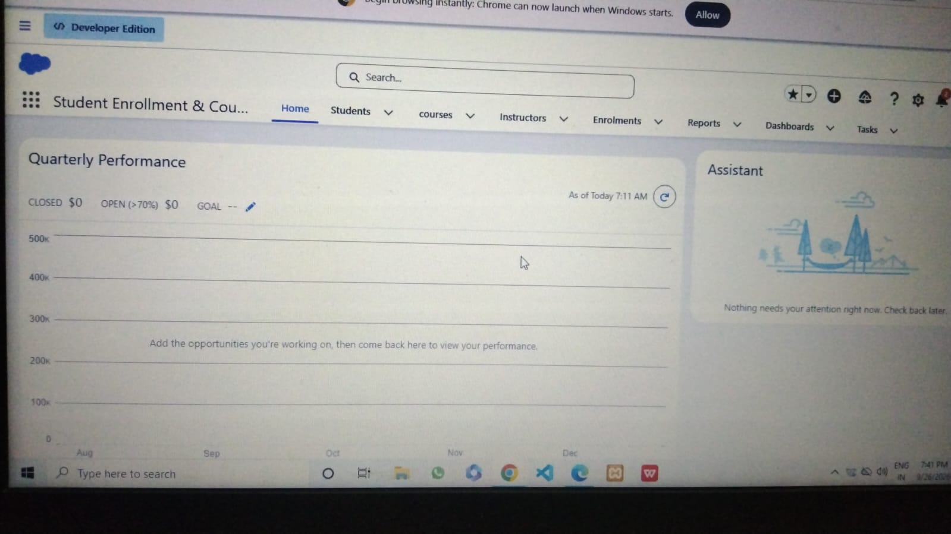

6.17. RECORD TYPES
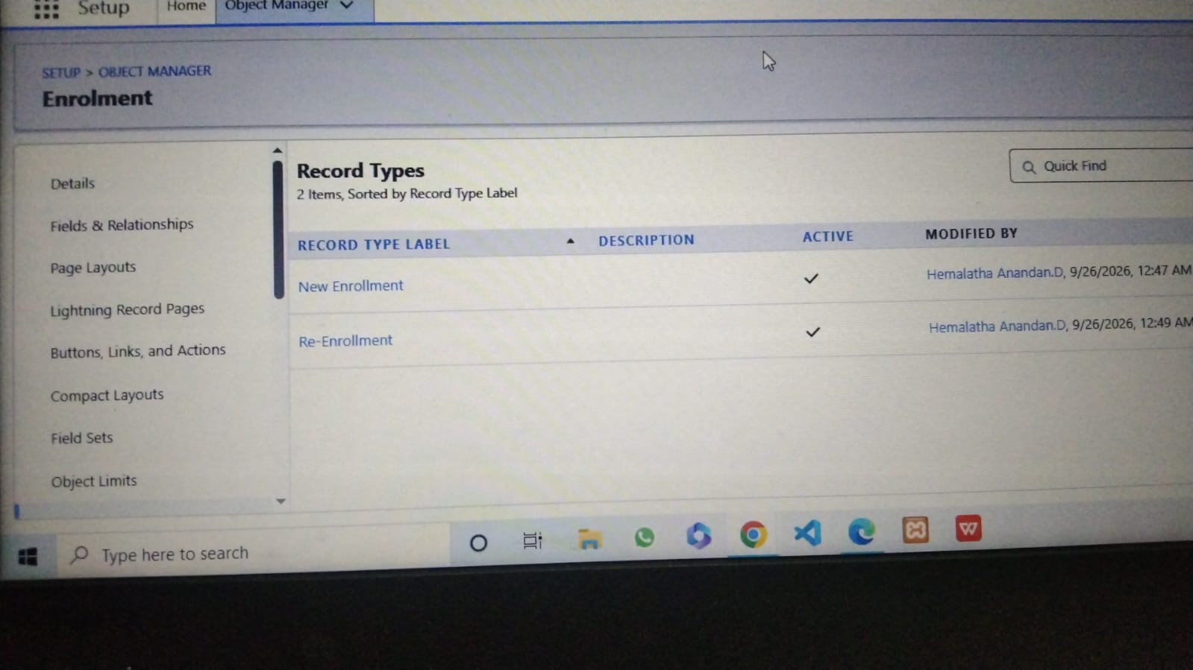

6.18. AUTOMATIC ENROLLMENT DATE
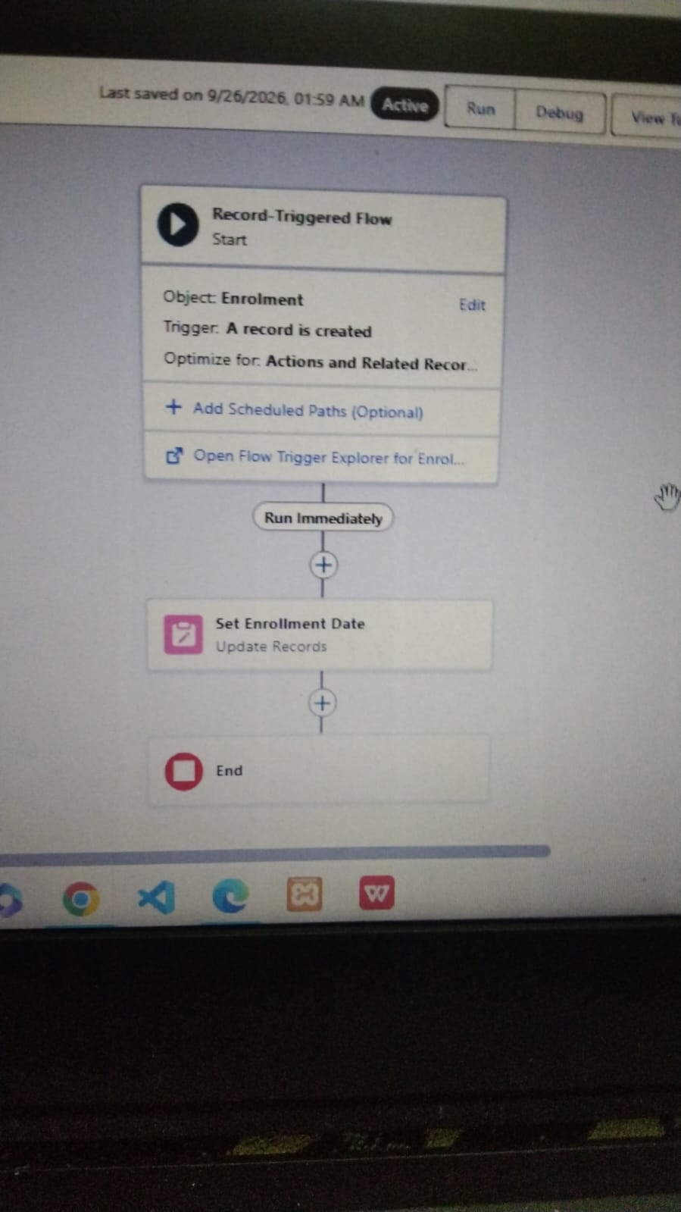

6.19. INSTRUCTOR ASSIGNMENT

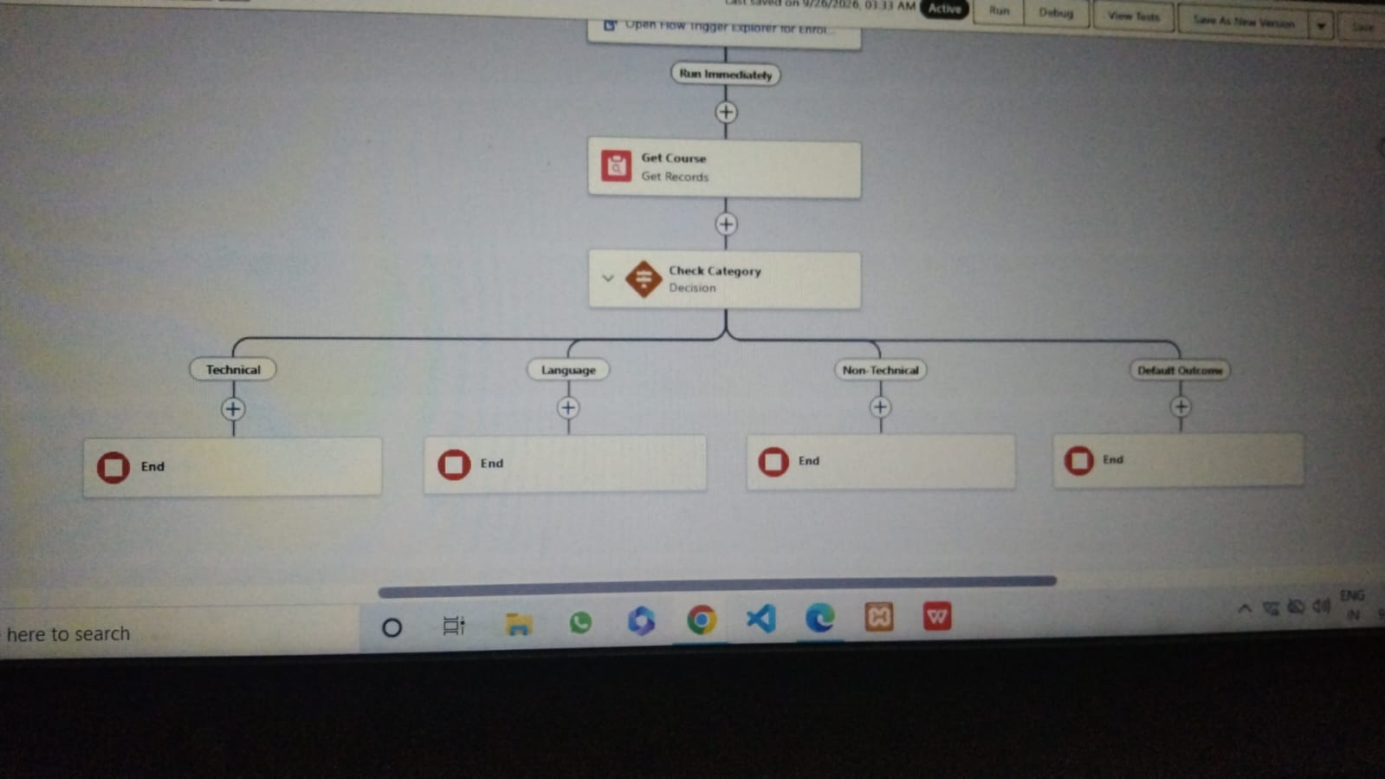

6.20. FLOW UP TASK

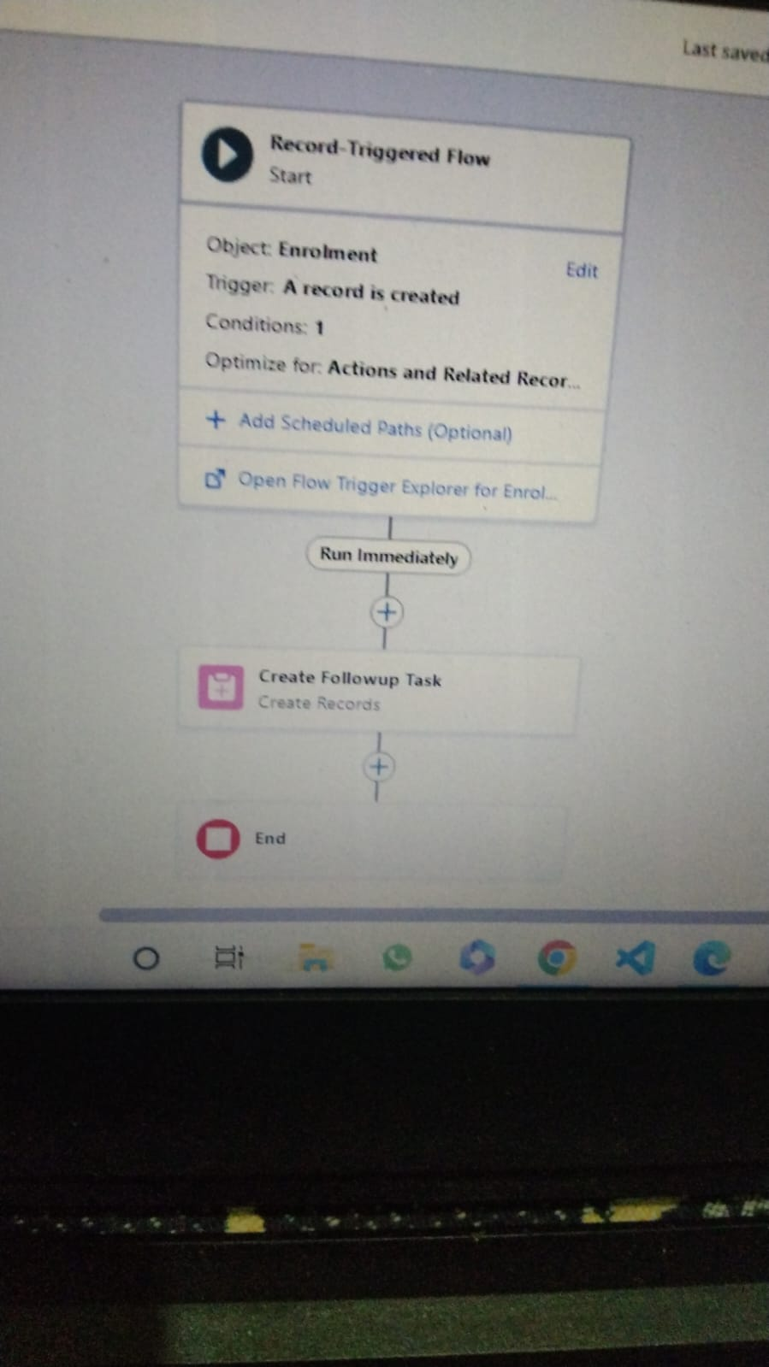

6.21. APPROVAL TASK
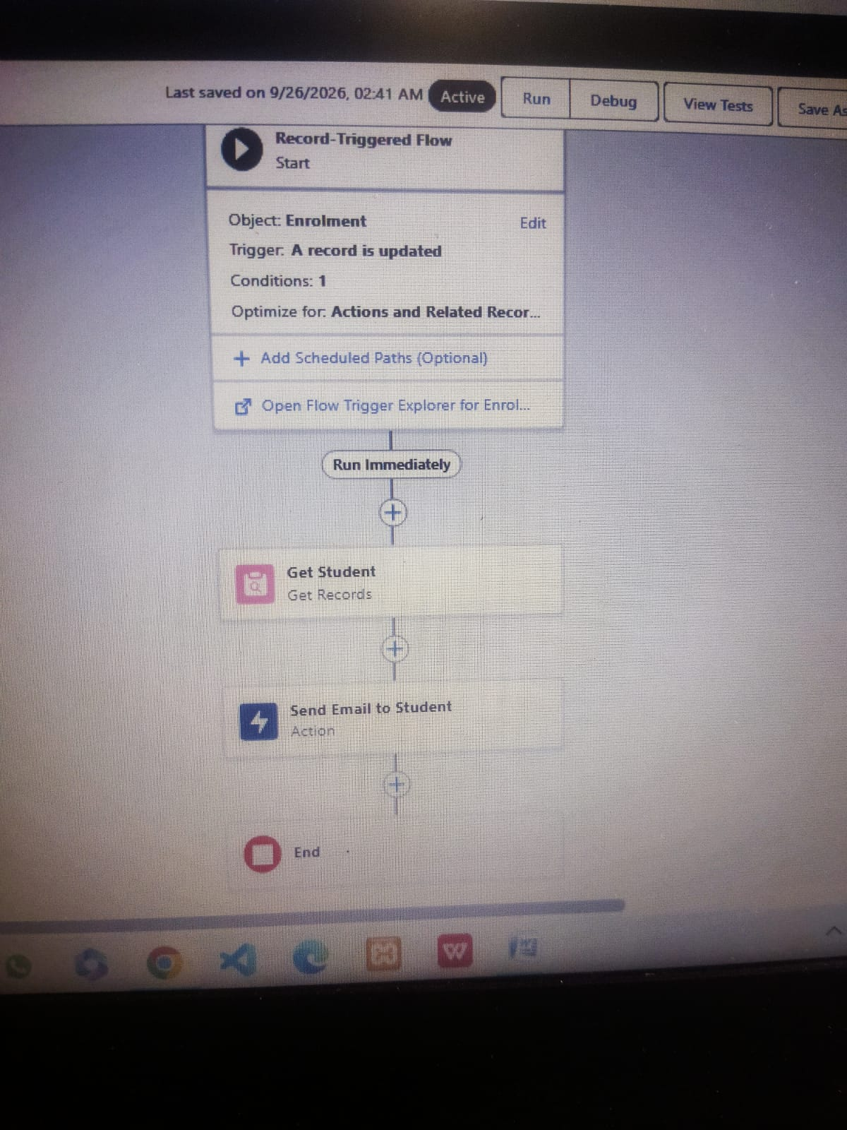

6.22. REPORTS TAB
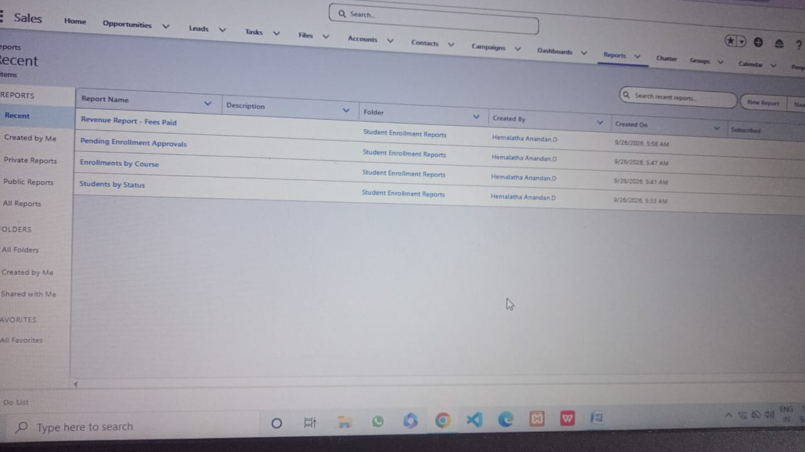
6.23. DASHBOARD TAB

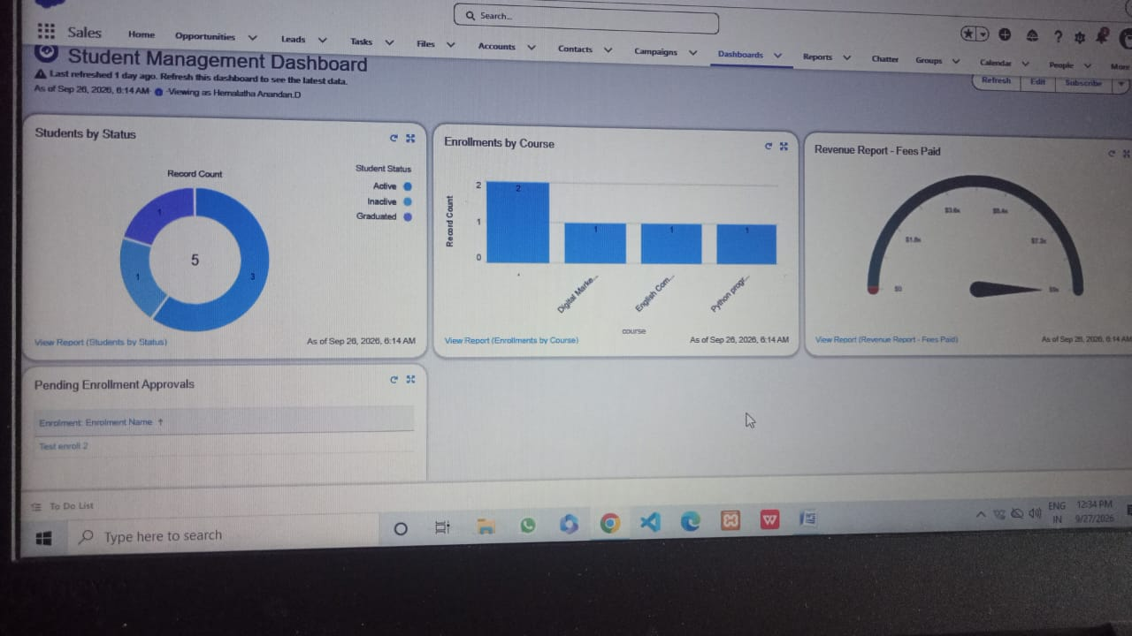

6.24. SHARING SETTING

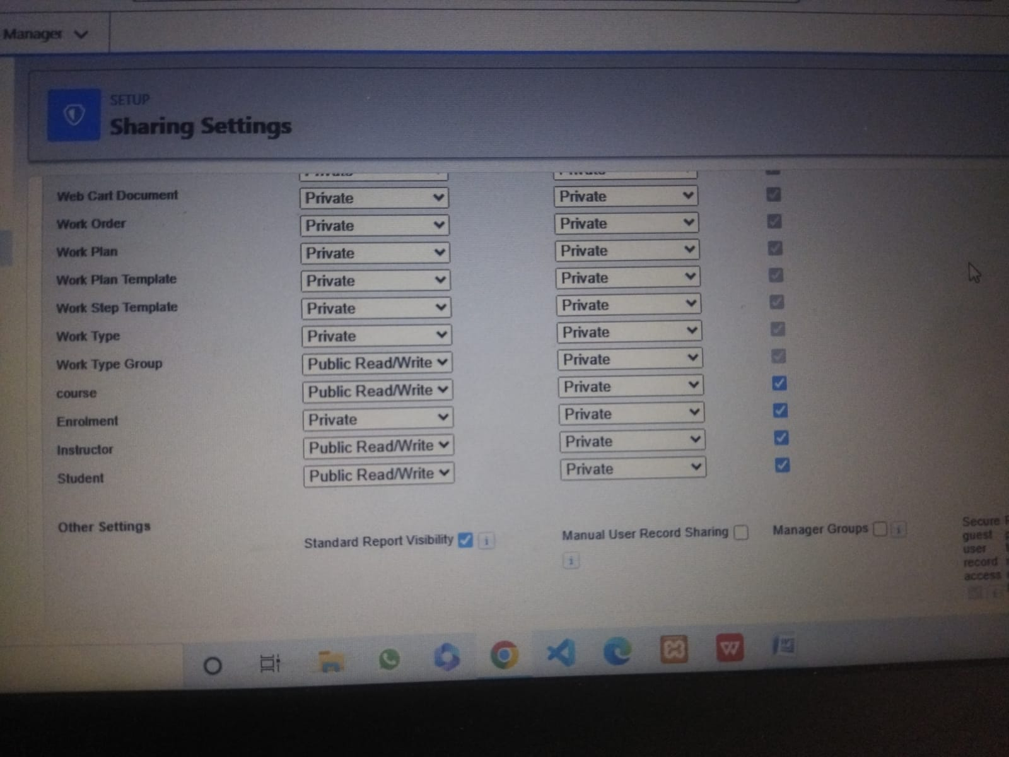

7. FUNCTIONAL & PERFORMANCE TESTING

7.1 Functional Testing:
New enrollment creation → Enrollment date auto-filled ✅ PassTechnical course selected → Technical instructor auto-assigned ✅ PassDuplicate student name → Duplicate warning shown ✅ PassEnrollment submitted → Approval request triggered ✅ Pass
7.2 Performance Testing:
System tested with bulk data import via Data Import Wizard. Record creation, flow execution, and dashboard load time were within acceptable limits.

8. ADVANTAGES & DISADVANTAGES
Advantages:
- Fully automated enrollment process reduces manual work.
- Data accuracy via validation and duplicate rules.
- Real-time dashboard for decision making.
- Secure role-based access.

Disadvantages:
- Requires Salesforce license cost.
- Internet dependency for access.
- Initial setup needs Salesforce knowledge.

CONCLUSION:

The Student Enrollment System project has been successfully designed and implemented on the Salesforce platform, meeting all the defined requirements and user stories. The system effectively automates the complete enrollment lifecycle, from student registration to final approval, significantly reducing manual effort and administrative overhead. Key accomplishments of this project include the creation of a well-structured data model with four custom objects, implementation of intelligent automation through Record-Triggered Flows for enrollment date and instructor assignment, and a robust approval process ensuring controlled enrollments. Data integrity is maintained through validation rules and duplicate rules, while security is enforced via custom profiles and role hierarchy. The interactive dashboard and reports provide administrators with real-time visibility into student statistics, course-wise enrollments, and revenue, enabling informed decision-making. This project demonstrates the power of Salesforce declarative development in building scalable, secure, and user-friendly business applications without extensive coding. Overall, the Student Enrollment System serves as a complete, efficient, and reliable solution for educational institutions to manage their admission process digitally.

FUTURE SCOPE:

- Integration with payment gateways for online fee collection.
- Email and SMS notifications for enrollment status updates.
- Student attendance tracking module.
- Mobile-friendly Lightning pages for enhanced accessibility.

